**19C Gravesend**

**Hayley Smith**

In the nineteenth century steamboats sailing to Gravesend transferred an influx of tourists to Rosherville Gardens, a Victorian pleasure garden built within an abandoned chalk pit owned by Jeremiah Rosher. Rosher made use of Gravesend’s popularity with Londoners and its proximity to the Thames, making it a popular tourist attraction before the rise of the railway and [seaside resorts](/19c/19c-seaside) impacted upon its revenue. Rosherville Gardens, described as a ‘place to spend a happy day’ in [E. Nesbit](/nesbit/nesbit-biography)’s _*The Story of the Amulet_* (1906),was a ‘favourite resort of Londoners. Adorned with small Greek temples and statuary set in the cliffs’, the gardens also contained ‘terraces, an archery lawn, [a] Bijou theatre, [a] Baronial Hall for refreshments, and at one time a lake’. [1] Firework displays, coloured lights, and dancers additionally illuminated the Gardens by night. Despite Rosherville’s decline by the end of the century, the attraction was a triumph earlier in the Victorian era; in fact, ‘in 1857 as many as 20,000 visitors passed through the turnstiles in one week’.[2] Rosherville Gardens received competition, but its rivals weren’t quite so successful: Victoria Gardens, for example, named after the Princess (later Queen), opened in 1834 and struggled to compete with Rosherville’s flood of Victorian pleasure-seekers. Located nearly a mile from the town, day-trippers chose instead to venture to closer pleasure gardens. The owner, John Robert Hall, consequently converted Victoria Gardens into a cemetery only three years later. Gravesend Cemetery – as it is known today – was designed with the help of Stephen Geary, the architect of the infamous Highgate Cemetery.

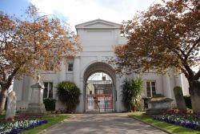   
Photo taken from: <http://www.discovergravesham.co.uk/gravesend/gravesend-cemetery.html> (not sure if this one is public domain!)

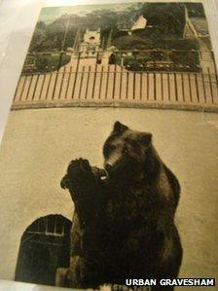  
Photo of “Rosie the bear”, an attraction in Rosherville Gardens. Image on BBC: <https://www.bbc.co.uk/news/uk-england-kent-25836375>

A fictional version of Rosherville, named Rosherwich Gardens, appears in the 1885 comic fantasy narrative, *The Tinted Venus*, written by Thomas Anstey Guthrie under the pen name ‘F. Anstey’. In this story, Rosherwich operates as a fantastical site where the unfortunate protagonist, Leander Tweddle, unwittingly animates a statue of the goddess Venus by placing a ring on her finger – a move which unsurprisingly wreaks havoc upon his life and his romantic entanglements. Visiting Rosherwich in autumn, presumably when the weather was starting to turn and the Gardens began to wind down, Tweddle details some of the remaining attractions: ‘a large building, in the Gothic style, with a Tudor doorway, known as the ‘Baronial All,’ where lights shone behind the painted windows’; an ‘open-air theatre, its drop-scene lowered, its proscenium lost in the gloom’; and ‘a circle for *al-fresco* dancing’.[3]

Although Rosherville closed its doors by the end of the century, the Gardens briefly reopened between 1903 and 1911, serving as a location in the making of early films. A horrific accident in 1878 made Rosherville famous for another reason, though. After departing from Rosherville pier, the *Princess Alice* passenger paddle steamer collided with the collier *Bywell Castle* on the Thames, killing approximately 600-700 people.

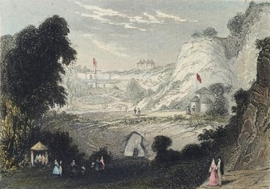  
Colour engraving of Rosherville Gardens – taken from ‘Rosherville Gardens’ on Wikipedia.

Two piers in Gravesend were also constructed during the nineteenth century: Gravesend Town Pier and the Royal Terrace Pier. The former, used by over three million passengers between 1835 and 1842, was built in 1834 and designed by William Tierney Clark. Around the same time that Rosherville Gardens closed the Town Pier also fell into disuse, as tourists often opted to travel by rail rather than by boat. Between 2000 and 2002, Gravesham council purchased the pier and worked on its restoration. It now remains the oldest surviving cast iron pier in the world and is a grade II listed building.[4] The Royal Terrace Pier was constructed in 1844 and designed by John Baldry Redman. Holding a royal claim to fame, on 7 March 1865 Princess Alexandra landed at this pier, disembarking to make her journey to marry Edward VII.[5]

For more on Rosherville Gardens, see Jonathan Peacock, ‘Rosherville Gardens – an Epitome of Victorian England’, _*Garden History_*39: 1 (2011). 64–82.

1. E. Nesbit. _*The Story of the Amulet_.* New York: E. P. Dutton and Company, n.d. [1906]). 333; Robert Hiscock. _*A History of Gravesend_.*Phillimore, 1976. 132.
2. Hiscock, p. 132.
3. F. Anstey, *The Tinted Venus* (New York and London: Harper and Publishers, repr. 1898 [1885]), pp. 14–15.
4. <https://piers.org.uk/piers/gravesend-town-pier/>
5. <https://historicengland.org.uk/listing/the-list/list-entry/1341489>